Year 7 Energy - Learning Journey
Lesson | Oi! Remember this!
1.)Types of energy
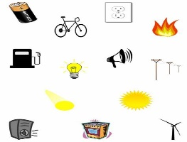 | How energy is stored
2.)Fuels
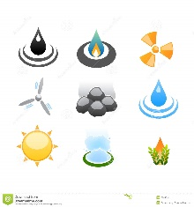 | Combustion transfers energy
3.)Fire Triangle
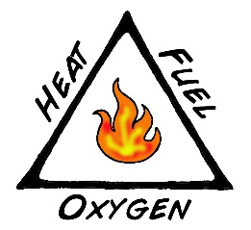 | Energy is stored in fuel and is transferred by Combustion
4-5.)Combustion Investigation
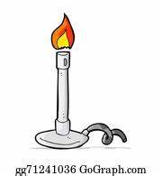 | Combustion transfers energy from fuels
6.)Explain how we are ‘fueled’
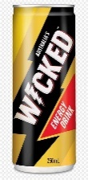 | How energy is stored
7.)Formation of Fossil Fuels
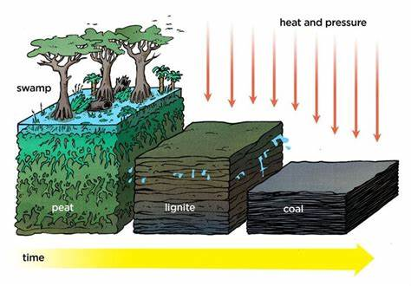 | There are different types of energy
8-9.)Renewable Energy sources
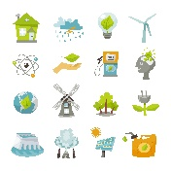 | Combustion releases CO₂
10.)Global Warming & Climate Change
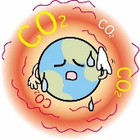
11.)Synoptic Assessment

