Year 7 Electricity - Learning Journey
Lesson | Oi! Remember this!
1a and b.) Conductors/Insulators | Conductors allow electricity to flow
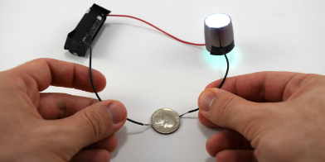
2.) Static electricity | Only negative charge moves…
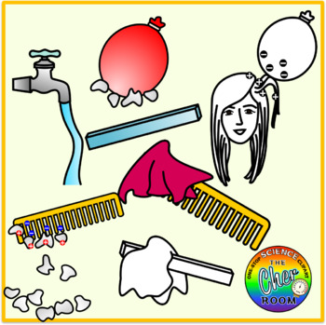
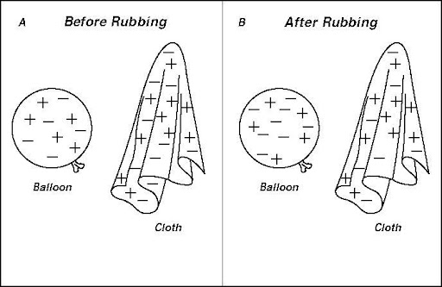  3,4&5.) Investigating charge | Moving charge = Electricity and it transfers energy
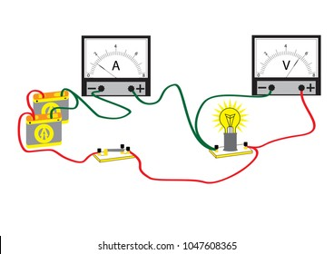  6.) Measuring energy in circuits | Voltage is a measure of energy
7.) Resistance of a wire | Resistance is anything that slows current
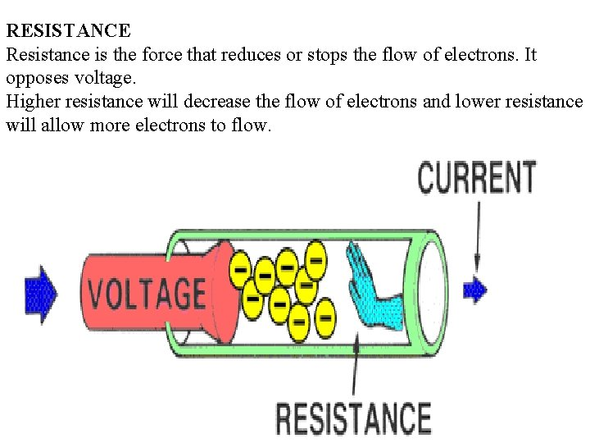
8.) Series circuits | Connected in a single loop
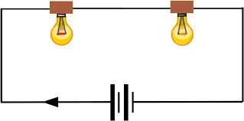
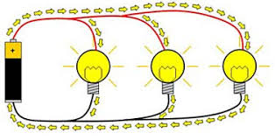  9.) Parallel circuits | Connected in branches
10.)Synoptic Assessment

