Year 7 - Life Learning Journey
Lesson | Oi! Remember this!
1.) Reproductive parts of plants.
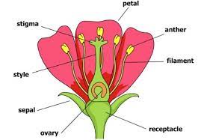 | Male Stamen make sperm, female Carpel holds ovum
2.) Adaptations for pollination.
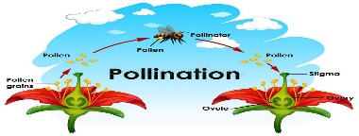 | Pollination when pollen lands on stigma and grows a pollen tube carrying nucleus to the ovum.
3.) Mechanisms for seed dispersal.
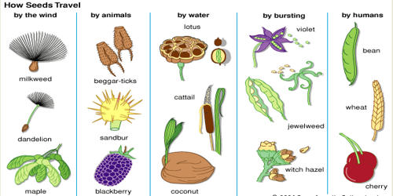 | There are many adaptations for seed dispersal so seedlings don’t have to compete with adult plants.
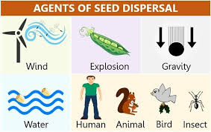
4.) Investigating seed dispersal.
 | There are many adaptations for seed dispersal.
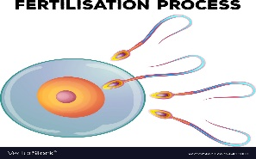
5.) Human reproductive organs and fertilization.
 | Fertilization is when sperm nucleus fuses with nucleus in the egg, occurs in Oviduct.
6.) Classify methods of contraception.
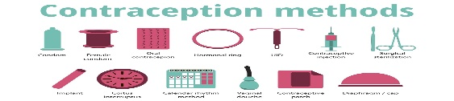 | Contraception is stopping pregnancy – either barrier or non-barrier.
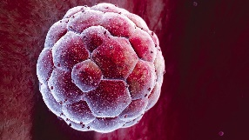
7.) Development of Embryo to Fetus.
 | Fertilized egg becomes a ball of cells – Embryo – which implants into the lining of the uterus forming a placenta.
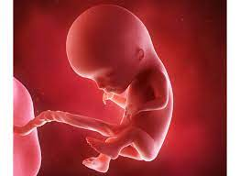
8.) Development of Fetus to birth.
 | Embryo develops into Fetus (limb buds). After 9 months is born. Contractions = uterus gets SMALLER.
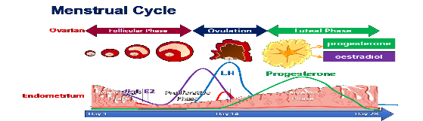
9.) Describe the Menstrual Cycle.
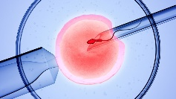 | Cycle is controlled by hormones and lasts 28 days..
10.) Describe I.V.F.
 | Egg is fertilized outside of the body.
11 & 12.) Describe changes at Puberty
 | Change from child to adult, controlled by hormones. Primary changes sperm made in males, eggs released in females.
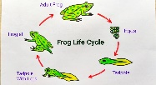
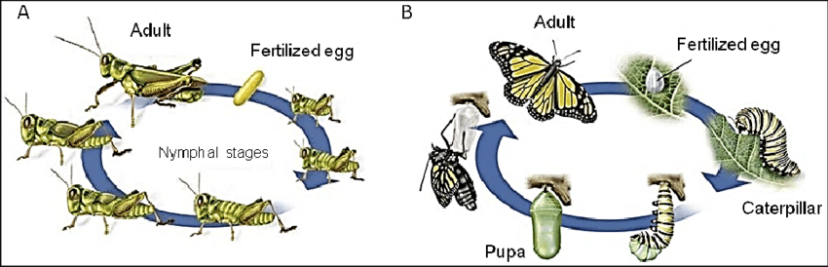
X and Y.) Lifecycles Insects and Frogs
 | Series of steps with defined stages and include metamorphosis.
13.)Synoptic Assessment

