Year Speed, Pressure & Moments Part 2 - Learning Journey
Lesson | Oi! Remember this!
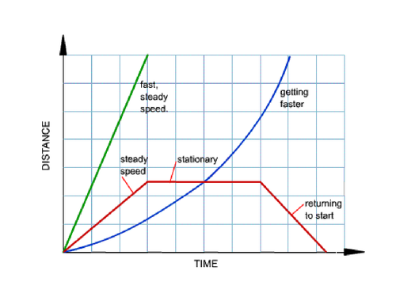  9.) Distance/time graphs | Rules for d/t graphs
10.) Velocity/time graph | Rules for v/t graphs
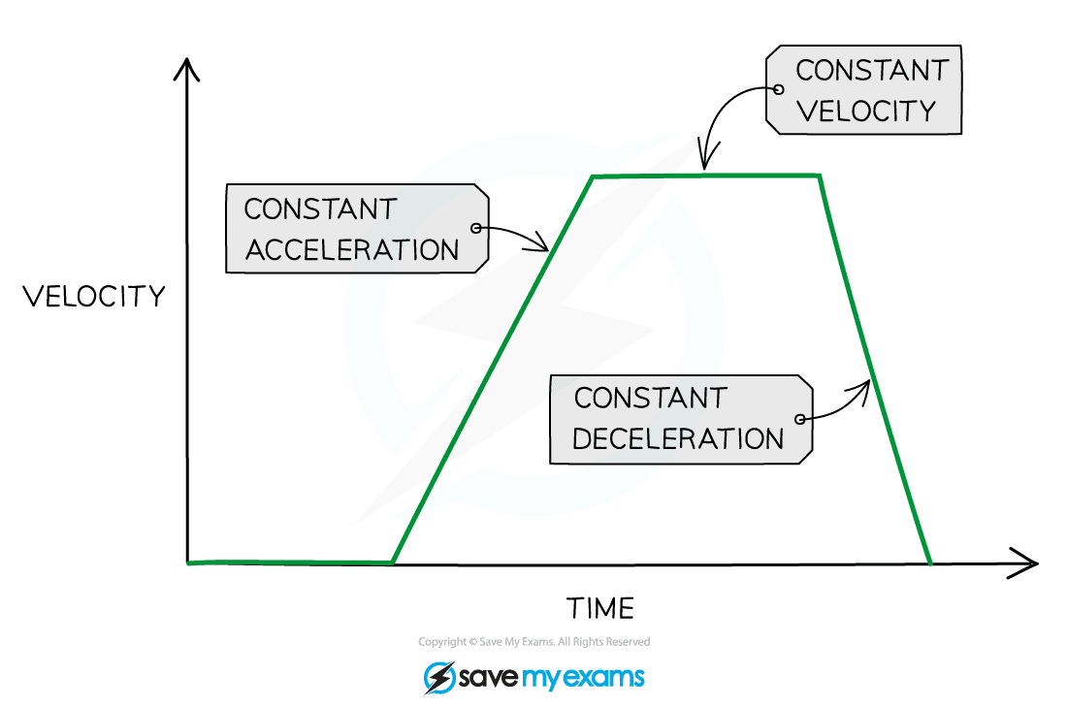
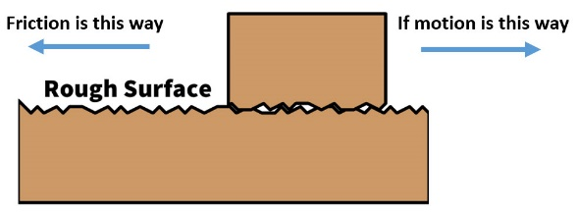  11.) Affecting Friction | Forces interact
12.) Levers | We can affect interacting forces
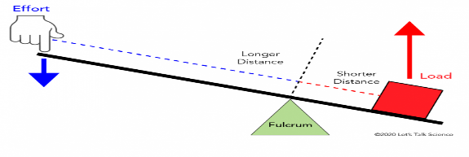
13.) Balanced Forces | Forces balanced = No change
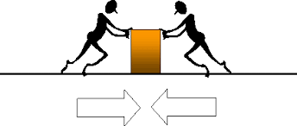
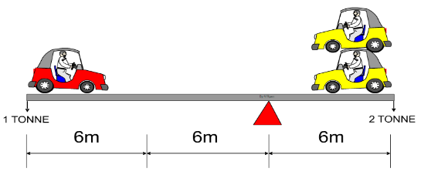  14.) Moments | Forces act on and over objects
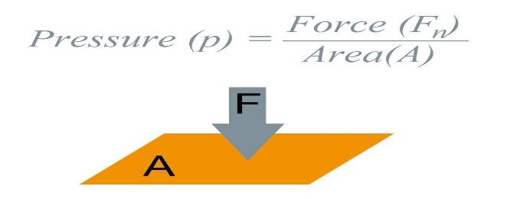
15.) Pressure | Measured in N/m² (bigger area = less pressure)
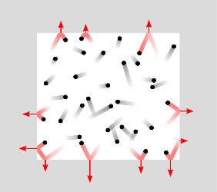
16.) Gas pressure | Increase depth, temp, decrease volume = increase pressure
7 – Particles (Pressure), Forces (Friction, balanced Forces)
8 – Space (Forces), Light & Sound (Speed)
17.)Synoptic Assessment

