Year 9 Energy & Electricity - Learning Journey
Lesson | Oi! Remember this!
1.) Sankey diagrams | Electricity is a form of energy transfer
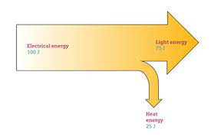
2.) Model electricity | Electrons flowing carry charge
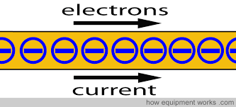
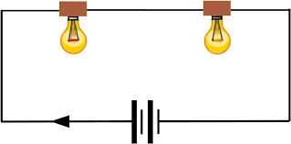  3.) Series circuits | Current is the same everywhere, voltage is shared by components
4.) Resistance and Ohm’s Law | Resistance slows flow; V = I x R
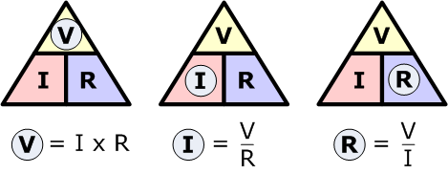
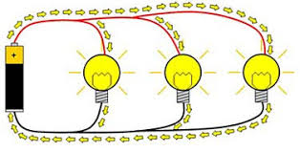  5.) Parallel circuits | Current is shared, voltage is the at each branch
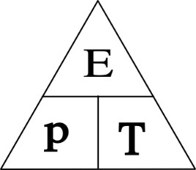  6.) Energy Transfer | Rate of transfer is Power (W)
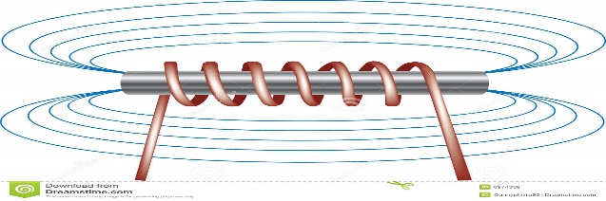  7.) Electromagnets and their uses | Current flowing induces Magnetic field
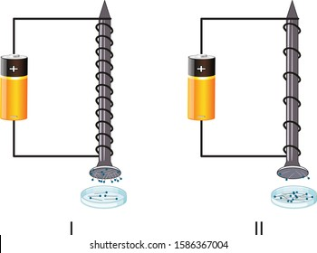  8 & 9.) Investigate electromagnets | We can manipulate electromagnets
7 – Electricity (circuits, charge, V =IxR), Energy (Sankey diagrams)
8 – Magnetism (electromagnets)
10.)Synoptic Assessment

