Dear Parent/Carer,

As you are aware the government has issued a level 4 UKHSA heat health alert for all England for Monday 18th and Tuesday 19th July. We have continued to open today and have closely monitored the situation, ensuring students have had access to water stations; we have also ventilated the classrooms as best as possible.

Although today has been manageable because the school was empty over the weekend, and therefore safe for students to attend; due to the school being an older building the classrooms are now reaching very high temperatures. This is making the working environment for our students and staff very uncomfortable.

The weather is due to be just as warm tomorrow, and for this reason we have chosen to close the school. We ask that all students stay at home tomorrow. Teachers will be uploading work onto Microsoft Teams for students to access from home.

We will reopen on Wednesday 20th July and ask students to return to school as normal at 8.45am. Temperatures are due to be much cooler by then.

Please note that Wednesday, Thursday and Friday this week will be a free non-school uniform days, so that students can wear appropriate clothing during this warmer weather. Please ensure that your child attends school wearing clothing that is appropriate for the school working environment. We would also like to take this opportunity to remind parents/carers that Friday 22nd July is our last day of the school term and we will be finishing at the earlier time of 12.30pm.

Yours faithfully,
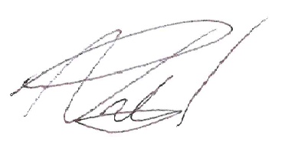

Neil Pritchard
Head Teacher

