Year 8 – Microbes Learning Journey
Lesson | Oi! Remember this!
1.) Types of Microbes
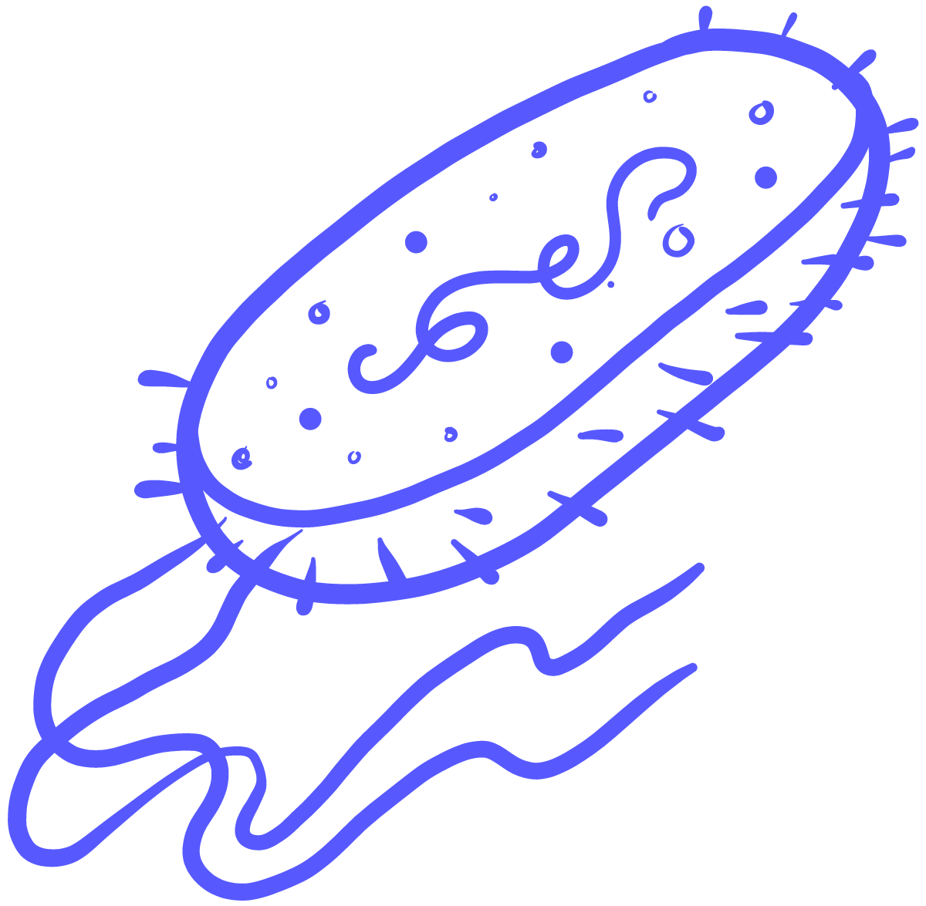  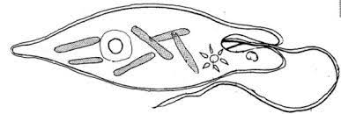  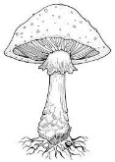  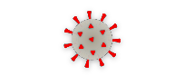 | The four types of microbes; Fungi, Viruses, Bacteria and Protozoa.
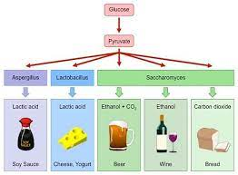
2.) The uses of microbes
 | Microbes have a range of uses including making food.
3.) Microbes in the gut
 | There are ‘good’ bacteria found in the gut.
4.) Microbes and the atmosphere
 | Bacteria helped change the entire atmosphere.
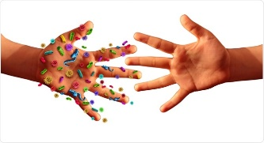
5.) How diseases are spread
 | Microbe infections spread by; contaminated food/water, droplets in the air and direct contact.
6.) Body defences against disease
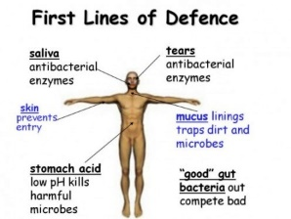 | The body has a range of defences which counter the modes of infection.
7.) Treatment and prevention
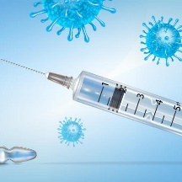 | Antibiotics don’t work on viruses. Vaccination tricks the body into making antibodies ready.
8.) Famous Microbiologists
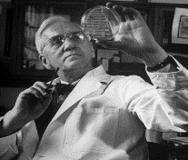 | Ideas of microbes and disease have changed over time.
10.)Synoptic Assessment Exam 3
Year 7 – Cells and Classification and Body systems

